SIMULATION STUDIES

The treatment effects is measured as the difference between and the predicted . Since the true DGP is unknown, the only way to consider which method is more likely to yield more accurate in a wide array of situations is to conduct computer simulations. In the DGPs below, we assume that the common factors , , and are ; the factor loadings , and are also , unless they are specified otherwise. The coefficients are set at and . The DGPs are designed as follows:

**DGP1.** Model with exogenous variables and common factors:

The covariates are (positively) correlated with the factors as follows:

，

where , and *.*

**DGP2.** Model with exogenous variables and common factors:

The covariates follow an autoregressive moving average (ARMA) process as

，

where and .

**DGP3.** Non-linearmodel with exogenous variables and common factors:

The covariates follow an autoregressive moving average (ARMA) process as

，

where and .

**DGP4.** DGP1 with heteroskedasticity:

where and .

**DGP5.** DGP1 with autocorrelation:

where and

**DGP6.** DGP1 with heteroscedasticity and autocorrelation:

where and

**DGP7.** DGP1 with stationary factors:

where , and are .

**DGP8.** DGP1 with one almost non-stationary factor:

where is .

**DGP9.** Pure factor model:

where not depended on . The covariates are (positively) correlated with factors as follows:

，

where , and *.*

The treatment and control groups consist of 1 and units, respectively. The treatment for unit 1 starts at time .The other units are not subject to treatment. We let and the pretreatment time as well. The posttreatment periods are set at ; that is, . The number of replications is set at .

We consider four criteria for comparison: the coverage probability of confidence interval for treatment effect (CP) at each post-treatment period, the width of confidence interval for treatment effect (WCI) at each post-treatment period, the mean of the sum of squared error for the actual outcomes and the counterfactuals at each post-treatment period (MSE), the median absolute deviation for the actual outcomes and the counterfactuals at each post-treatment period(MAD). We consider the performances obtained by constructing the counterfactuals of via QCM and QCMX. The simulation results are summarized in Tables 1 –7. We also plot simulation results for DGPs 1–7 when N = 40 and T = 60 in Figures 1– 7. In general, we find that

(1) When the outcome variable is depended on covariates (DGP 1-6), QCMX method is able to approximately dominate QCM all of the times, adding covariates to help predict that greater confidence probability, narrower confidence interval, lesser MSE and lesser MAD to be obtained.

(2) When the outcome variable is not depended on covariates (DGP 7), the QCMX method adds interference variables unrelated to the outcome variable compared with QCM method, which makes the confidence interval wider and MSE larger, but has no significant impact on CP and WCI.

TABLE 1 Simulation results of QCM and QCMX methods for DGP1

|  |  |  |  |  |  |  |  |  |  |
| --- | --- | --- | --- | --- | --- | --- | --- | --- | --- |
| T0 | Time | CP | | MAD | | MSE | | WCI | |
| N=40 |  | QCM | QCMX | QCM | QCMX | QCM | QCMX | QCM | QCMX |
| 40 | 1 | 0.917 | 0.938 | 4.054 | 3.236 | 45.557 | 31.894 | 26.829 | 26.146 |
| 2 | 0.926 | 0.949 | 4.341 | 3.291 | 46.967 | 33.275 | 27.153 | 26.692 |
| 3 | 0.919 | 0.937 | 4.361 | 3.280 | 51.954 | 35.811 | 27.124 | 26.762 |
| 4 | 0.893 | 0.926 | 4.544 | 3.411 | 58.137 | 41.288 | 27.330 | 27.041 |
| 5 | 0.895 | 0.924 | 4.542 | 3.404 | 63.075 | 43.881 | 27.307 | 27.007 |
| 6 | 0.894 | 0.918 | 4.583 | 3.465 | 64.186 | 44.776 | 27.181 | 27.040 |
| 7 | 0.896 | 0.917 | 4.785 | 3.532 | 67.631 | 48.319 | 27.537 | 26.976 |
| 8 | 0.894 | 0.918 | 4.644 | 3.428 | 67.342 | 46.868 | 27.734 | 27.426 |
| 9 | 0.894 | 0.912 | 4.577 | 3.396 | 64.789 | 46.424 | 27.176 | 27.031 |
| 10 | 0.886 | 0.918 | 4.571 | 3.532 | 66.521 | 47.293 | 27.622 | 27.433 |
| 70 | 1 | 0.936 | 0.966 | 4.195 | 2.810 | 42.242 | 22.197 | 26.358 | 24.895 |
| 2 | 0.933 | 0.965 | 4.228 | 2.879 | 44.926 | 24.006 | 26.608 | 25.225 |
| 3 | 0.926 | 0.956 | 4.435 | 2.909 | 50.836 | 26.935 | 26.907 | 25.293 |
| 4 | 0.919 | 0.951 | 4.312 | 2.890 | 50.642 | 27.786 | 26.878 | 25.399 |
| 5 | 0.924 | 0.951 | 4.405 | 2.961 | 50.785 | 28.204 | 26.794 | 25.240 |
| 6 | 0.927 | 0.961 | 4.457 | 2.962 | 50.395 | 28.682 | 26.831 | 25.335 |
| 7 | 0.928 | 0.958 | 4.290 | 3.034 | 49.593 | 29.591 | 26.733 | 25.300 |
| 8 | 0.929 | 0.962 | 4.616 | 3.127 | 50.901 | 28.887 | 26.815 | 25.472 |
| 9 | 0.925 | 0.959 | 4.436 | 3.074 | 50.413 | 29.090 | 26.926 | 25.682 |
| 10 | 0.919 | 0.954 | 4.310 | 2.908 | 50.493 | 29.046 | 26.820 | 25.638 |
| N=70 |  | QCM | QCMX | QCM | QCMX | QCM | QCMX | QCM | QCMX |
| 40 | 1 | 0.926 | 0.943 | 4.014 | 3.211 | 41.726 | 29.745 | 26.541 | 26.473 |
| 2 | 0.917 | 0.933 | 4.294 | 3.349 | 45.695 | 33.415 | 26.832 | 26.834 |
| 3 | 0.909 | 0.928 | 4.397 | 3.536 | 49.275 | 36.181 | 26.979 | 27.091 |
| 4 | 0.908 | 0.931 | 4.385 | 3.442 | 51.485 | 37.285 | 26.820 | 27.097 |
| 5 | 0.899 | 0.923 | 4.691 | 3.650 | 53.883 | 39.856 | 27.054 | 27.311 |
| 6 | 0.902 | 0.926 | 4.316 | 3.485 | 53.398 | 39.392 | 27.174 | 27.279 |
| 7 | 0.913 | 0.934 | 4.570 | 3.628 | 51.085 | 37.309 | 27.172 | 27.389 |
| 8 | 0.909 | 0.931 | 4.578 | 3.645 | 53.420 | 39.434 | 27.209 | 27.431 |
| 9 | 0.908 | 0.932 | 4.289 | 3.502 | 52.306 | 38.246 | 27.230 | 27.511 |
| 10 | 0.917 | 0.929 | 4.382 | 3.419 | 54.872 | 41.094 | 27.286 | 27.501 |
| 70 | 1 | 0.940 | 0.965 | 3.875 | 2.694 | 36.639 | 21.141 | 25.916 | 24.564 |
| 2 | 0.943 | 0.963 | 4.228 | 3.009 | 43.298 | 25.391 | 26.234 | 24.819 |
| 3 | 0.931 | 0.953 | 4.083 | 2.901 | 44.210 | 26.339 | 26.191 | 25.072 |
| 4 | 0.923 | 0.954 | 4.280 | 3.028 | 48.234 | 28.820 | 26.284 | 25.110 |
| 5 | 0.926 | 0.952 | 4.295 | 2.942 | 47.838 | 29.166 | 26.458 | 25.110 |
| 6 | 0.925 | 0.952 | 4.603 | 3.032 | 49.732 | 30.594 | 26.226 | 25.102 |
| 7 | 0.927 | 0.949 | 4.269 | 2.937 | 49.914 | 30.961 | 26.295 | 25.316 |
| 8 | 0.928 | 0.954 | 4.228 | 2.948 | 48.792 | 29.101 | 26.391 | 25.273 |
| 9 | 0.926 | 0.954 | 4.343 | 3.043 | 46.869 | 28.363 | 26.470 | 25.385 |
| 10 | 0.917 | 0.949 | 4.495 | 3.006 | 50.386 | 30.607 | 26.325 | 25.350 |

TABLE 2 Simulation results of QCM and QCMX methods for DGP2

|  |  |  |  |  |  |  |  |  |  |
| --- | --- | --- | --- | --- | --- | --- | --- | --- | --- |
| T0 | Time | CP | | MAD | | MSE | | WCI | |
| N=40 |  | QCM | QCMX | QCM | QCMX | QCM | QCMX | QCM | QCMX |
| 40 | 1 | 0.894 | 0.926 | 5.388 | 3.271 | 71.123 | 37.627 | 28.707 | 27.480 |
| 2 | 0.886 | 0.928 | 5.598 | 3.309 | 74.441 | 39.117 | 29.103 | 27.992 |
| 3 | 0.893 | 0.928 | 5.873 | 3.467 | 79.651 | 42.014 | 29.138 | 28.182 |
| 4 | 0.886 | 0.929 | 5.682 | 3.499 | 79.544 | 42.004 | 29.261 | 28.226 |
| 5 | 0.890 | 0.934 | 5.763 | 3.417 | 83.560 | 43.468 | 29.134 | 28.532 |
| 6 | 0.894 | 0.923 | 5.464 | 3.219 | 81.593 | 44.013 | 29.218 | 28.526 |
| 7 | 0.888 | 0.923 | 5.929 | 3.546 | 87.381 | 47.140 | 29.189 | 28.397 |
| 8 | 0.872 | 0.912 | 5.903 | 3.599 | 88.462 | 47.493 | 29.300 | 28.452 |
| 9 | 0.873 | 0.927 | 5.732 | 3.470 | 88.290 | 48.357 | 29.116 | 28.472 |
| 10 | 0.875 | 0.913 | 5.879 | 3.578 | 88.678 | 48.794 | 29.251 | 28.505 |
| 70 | 1 | 0.910 | 0.954 | 5.397 | 2.855 | 70.502 | 28.901 | 29.315 | 26.933 |
| 2 | 0.917 | 0.960 | 5.381 | 2.752 | 69.157 | 27.688 | 29.511 | 27.126 |
| 3 | 0.904 | 0.948 | 5.465 | 2.779 | 77.429 | 31.974 | 29.644 | 27.492 |
| 4 | 0.899 | 0.949 | 5.473 | 2.833 | 79.162 | 33.262 | 29.612 | 27.643 |
| 5 | 0.903 | 0.947 | 5.703 | 2.987 | 80.916 | 33.708 | 29.587 | 27.635 |
| 6 | 0.896 | 0.942 | 5.488 | 2.883 | 80.070 | 34.247 | 29.689 | 27.646 |
| 7 | 0.891 | 0.942 | 5.830 | 3.045 | 85.142 | 36.219 | 29.673 | 27.678 |
| 8 | 0.905 | 0.946 | 5.667 | 2.958 | 81.117 | 34.489 | 29.740 | 27.734 |
| 9 | 0.904 | 0.945 | 5.703 | 2.945 | 81.515 | 34.491 | 29.657 | 27.629 |
| 10 | 0.916 | 0.957 | 5.490 | 2.889 | 78.530 | 33.204 | 29.879 | 27.775 |
| N=70 |  | QCM | QCMX | QCM | QCMX | QCM | QCMX | QCM | QCMX |
| 40 | 1 | 0.908 | 0.942 | 5.067 | 3.283 | 63.763 | 34.865 | 28.629 | 27.564 |
| 2 | 0.901 | 0.936 | 5.424 | 3.423 | 72.354 | 40.101 | 28.913 | 28.147 |
| 3 | 0.902 | 0.931 | 5.466 | 3.421 | 76.044 | 43.085 | 29.259 | 28.296 |
| 4 | 0.888 | 0.924 | 5.638 | 3.505 | 81.476 | 45.981 | 29.146 | 28.308 |
| 5 | 0.889 | 0.923 | 5.690 | 3.564 | 84.407 | 47.789 | 29.140 | 28.412 |
| 6 | 0.886 | 0.924 | 5.768 | 3.515 | 82.995 | 46.819 | 29.278 | 28.468 |
| 7 | 0.889 | 0.921 | 5.811 | 3.557 | 85.442 | 49.194 | 29.344 | 28.637 |
| 8 | 0.887 | 0.923 | 5.494 | 3.678 | 83.952 | 47.907 | 29.293 | 28.591 |
| 9 | 0.894 | 0.924 | 5.585 | 3.634 | 81.923 | 46.562 | 29.318 | 28.478 |
| 10 | 0.894 | 0.927 | 5.548 | 3.468 | 80.847 | 46.470 | 29.233 | 28.511 |
| 70 | 1 | 0.925 | 0.960 | 5.066 | 2.897 | 64.207 | 27.510 | 29.584 | 27.268 |
| 2 | 0.910 | 0.958 | 5.249 | 2.952 | 74.085 | 32.522 | 29.754 | 27.764 |
| 3 | 0.919 | 0.958 | 5.408 | 2.843 | 71.420 | 30.963 | 29.844 | 27.901 |
| 4 | 0.923 | 0.960 | 5.542 | 2.911 | 73.641 | 31.848 | 29.948 | 27.993 |
| 5 | 0.910 | 0.954 | 5.912 | 3.054 | 81.692 | 36.224 | 30.098 | 28.070 |
| 6 | 0.911 | 0.953 | 5.396 | 2.920 | 79.294 | 34.804 | 30.129 | 28.089 |
| 7 | 0.907 | 0.951 | 5.469 | 2.946 | 80.400 | 35.771 | 29.996 | 28.066 |
| 8 | 0.896 | 0.948 | 5.620 | 2.999 | 82.671 | 37.161 | 29.943 | 28.118 |
| 9 | 0.899 | 0.944 | 5.716 | 3.032 | 85.715 | 39.007 | 30.040 | 28.047 |
| 10 | 0.906 | 0.950 | 5.855 | 3.075 | 82.494 | 35.601 | 29.977 | 28.107 |

TABLE 3 Simulation results of QCM and QCMX methods for DGP3

|  |  |  |  |  |  |  |  |  |  |
| --- | --- | --- | --- | --- | --- | --- | --- | --- | --- |
| T0 | Time | CP | | MAD | | MSE | | WCI | |
| N=40 |  | QCM | QCMX | QCM | QCMX | QCM | QCMX | QCM | QCMX |
| 40 | 1 | 0.907 | 0.913 | 1.077 | 1.072 | 2.161 | 2.139 | 3.808 | 3.886 |
| 2 | 0.896 | 0.906 | 1.087 | 1.070 | 2.153 | 2.128 | 3.798 | 3.906 |
| 3 | 0.908 | 0.919 | 1.065 | 1.085 | 2.141 | 2.118 | 3.807 | 3.925 |
| 4 | 0.915 | 0.923 | 1.087 | 1.084 | 2.105 | 2.087 | 3.828 | 3.920 |
| 5 | 0.922 | 0.930 | 1.075 | 1.067 | 2.114 | 2.133 | 3.800 | 3.920 |
| 6 | 0.913 | 0.926 | 1.066 | 1.063 | 2.046 | 2.013 | 3.801 | 3.926 |
| 7 | 0.908 | 0.918 | 1.049 | 1.048 | 2.102 | 2.094 | 3.793 | 3.915 |
| 8 | 0.909 | 0.927 | 1.086 | 1.082 | 2.110 | 2.090 | 3.792 | 3.938 |
| 9 | 0.925 | 0.927 | 1.072 | 1.085 | 2.133 | 2.130 | 3.804 | 3.931 |
| 10 | 0.926 | 0.929 | 1.065 | 1.064 | 2.144 | 2.105 | 3.832 | 3.924 |
| 70 | 1 | 0.924 | 0.930 | 1.049 | 1.046 | 2.053 | 2.064 | 3.851 | 3.913 |
| 2 | 0.911 | 0.924 | 1.053 | 1.070 | 2.171 | 2.130 | 3.848 | 3.919 |
| 3 | 0.923 | 0.930 | 1.079 | 1.073 | 2.108 | 2.085 | 3.863 | 3.926 |
| 4 | 0.924 | 0.930 | 1.054 | 1.040 | 2.071 | 2.053 | 3.867 | 3.937 |
| 5 | 0.923 | 0.929 | 1.072 | 1.059 | 2.141 | 2.116 | 3.871 | 3.932 |
| 6 | 0.914 | 0.924 | 1.108 | 1.092 | 2.199 | 2.177 | 3.867 | 3.950 |
| 7 | 0.906 | 0.917 | 1.077 | 1.089 | 2.126 | 2.114 | 3.850 | 3.932 |
| 8 | 0.931 | 0.938 | 1.069 | 1.037 | 2.078 | 2.050 | 3.872 | 3.969 |
| 9 | 0.917 | 0.929 | 1.095 | 1.091 | 2.110 | 2.082 | 3.860 | 3.965 |
| 10 | 0.919 | 0.922 | 1.088 | 1.078 | 2.139 | 2.111 | 3.846 | 3.939 |
| N=70 |  | QCM | QCMX | QCM | QCMX | QCM | QCMX | QCM | QCMX |
| 40 | 1 | 0.903 | 0.899 | 1.076 | 1.075 | 2.135 | 2.136 | 3.854 | 3.893 |
| 2 | 0.916 | 0.923 | 1.134 | 1.142 | 2.211 | 2.194 | 3.865 | 3.936 |
| 3 | 0.915 | 0.921 | 1.058 | 1.047 | 2.147 | 2.128 | 3.862 | 3.942 |
| 4 | 0.916 | 0.925 | 1.107 | 1.106 | 2.096 | 2.080 | 3.850 | 3.941 |
| 5 | 0.906 | 0.907 | 1.061 | 1.064 | 2.182 | 2.161 | 3.861 | 3.939 |
| 6 | 0.905 | 0.919 | 1.076 | 1.066 | 2.110 | 2.097 | 3.845 | 3.938 |
| 7 | 0.909 | 0.912 | 1.091 | 1.094 | 2.214 | 2.192 | 3.863 | 3.949 |
| 8 | 0.912 | 0.918 | 1.123 | 1.103 | 2.225 | 2.212 | 3.853 | 3.951 |
| 9 | 0.920 | 0.930 | 1.062 | 1.079 | 2.114 | 2.111 | 3.847 | 3.951 |
| 10 | 0.914 | 0.927 | 1.080 | 1.074 | 2.107 | 2.099 | 3.845 | 3.946 |
| 70 | 1 | 0.929 | 0.935 | 1.037 | 1.055 | 2.069 | 2.051 | 3.898 | 3.933 |
| 2 | 0.923 | 0.924 | 1.068 | 1.058 | 2.118 | 2.101 | 3.902 | 3.959 |
| 3 | 0.913 | 0.925 | 1.089 | 1.093 | 2.144 | 2.113 | 3.886 | 3.948 |
| 4 | 0.928 | 0.940 | 1.053 | 1.047 | 2.094 | 2.092 | 3.900 | 3.960 |
| 5 | 0.934 | 0.939 | 1.078 | 1.073 | 2.018 | 2.002 | 3.893 | 3.959 |
| 6 | 0.919 | 0.926 | 1.084 | 1.091 | 2.158 | 2.140 | 3.890 | 3.960 |
| 7 | 0.927 | 0.935 | 1.040 | 1.047 | 2.055 | 2.055 | 3.886 | 3.950 |
| 8 | 0.922 | 0.930 | 1.066 | 1.042 | 2.058 | 2.020 | 3.913 | 3.962 |
| 9 | 0.917 | 0.918 | 1.037 | 1.019 | 2.155 | 2.142 | 3.902 | 3.980 |
| 10 | 0.924 | 0.933 | 1.051 | 1.051 | 2.024 | 2.004 | 3.918 | 3.971 |

TABLE 4 Simulation results of QCM and QCMX methods for DGP4

|  |  |  |  |  |  |  |  |  |  |
| --- | --- | --- | --- | --- | --- | --- | --- | --- | --- |
| T0 | Time | CP | | MAD | | MSE | | WCI | |
| N=40 |  | QCM | QCMX | QCM | QCMX | QCM | QCMX | QCM | QCMX |
| 40 | 1 | 0.907 | 0.925 | 4.174 | 3.098 | 47.463 | 31.392 | 26.562 | 26.020 |
| 2 | 0.906 | 0.926 | 4.465 | 3.287 | 51.440 | 34.043 | 27.052 | 26.568 |
| 3 | 0.893 | 0.917 | 4.482 | 3.167 | 55.365 | 36.354 | 27.232 | 26.551 |
| 4 | 0.898 | 0.921 | 4.492 | 3.399 | 54.067 | 36.171 | 27.436 | 27.065 |
| 5 | 0.903 | 0.924 | 4.483 | 3.427 | 55.775 | 37.982 | 27.309 | 27.193 |
| 6 | 0.902 | 0.927 | 4.529 | 3.232 | 57.706 | 38.211 | 27.311 | 27.006 |
| 7 | 0.897 | 0.923 | 4.424 | 3.323 | 56.909 | 38.796 | 27.602 | 27.169 |
| 8 | 0.887 | 0.918 | 4.688 | 3.354 | 60.962 | 41.426 | 27.266 | 27.028 |
| 9 | 0.904 | 0.924 | 4.367 | 3.361 | 58.210 | 40.236 | 27.426 | 27.285 |
| 10 | 0.898 | 0.921 | 4.382 | 3.377 | 59.662 | 40.963 | 27.608 | 27.286 |
| 70 | 1 | 0.941 | 0.965 | 4.122 | 2.735 | 40.134 | 21.030 | 26.003 | 24.381 |
| 2 | 0.930 | 0.954 | 4.030 | 2.721 | 41.431 | 22.722 | 26.110 | 24.442 |
| 3 | 0.933 | 0.960 | 4.280 | 2.748 | 44.575 | 24.143 | 26.059 | 24.671 |
| 4 | 0.924 | 0.949 | 4.497 | 2.879 | 46.611 | 26.086 | 26.206 | 24.675 |
| 5 | 0.927 | 0.953 | 4.063 | 2.696 | 44.725 | 24.667 | 26.312 | 24.691 |
| 6 | 0.924 | 0.957 | 4.070 | 2.702 | 46.855 | 25.369 | 26.544 | 24.926 |
| 7 | 0.935 | 0.963 | 4.305 | 2.776 | 49.126 | 26.358 | 26.688 | 25.241 |
| 8 | 0.924 | 0.960 | 4.198 | 2.725 | 51.107 | 28.423 | 26.500 | 25.185 |
| 9 | 0.918 | 0.955 | 4.267 | 2.873 | 51.332 | 29.068 | 26.601 | 25.154 |
| 10 | 0.917 | 0.945 | 4.238 | 2.811 | 52.869 | 29.956 | 26.682 | 25.102 |
| N=70 |  | QCM | QCMX | QCM | QCMX | QCM | QCMX | QCM | QCMX |
| 40 | 1 | 0.922 | 0.941 | 3.867 | 3.127 | 39.363 | 28.640 | 26.234 | 26.143 |
| 2 | 0.916 | 0.932 | 4.214 | 3.261 | 46.483 | 33.809 | 26.733 | 26.799 |
| 3 | 0.917 | 0.940 | 4.294 | 3.432 | 49.309 | 35.226 | 26.838 | 27.061 |
| 4 | 0.909 | 0.933 | 4.371 | 3.555 | 50.494 | 36.600 | 26.832 | 26.974 |
| 5 | 0.896 | 0.919 | 4.513 | 3.529 | 51.879 | 38.500 | 26.817 | 27.057 |
| 6 | 0.911 | 0.929 | 4.467 | 3.531 | 49.682 | 35.370 | 26.942 | 26.973 |
| 7 | 0.892 | 0.915 | 4.544 | 3.558 | 54.463 | 41.232 | 26.868 | 26.966 |
| 8 | 0.893 | 0.920 | 4.485 | 3.587 | 56.764 | 40.658 | 27.041 | 27.075 |
| 9 | 0.898 | 0.919 | 4.540 | 3.456 | 57.924 | 42.960 | 27.037 | 27.064 |
| 10 | 0.905 | 0.927 | 4.600 | 3.526 | 56.635 | 41.988 | 27.042 | 27.173 |
| 70 | 1 | 0.945 | 0.966 | 4.010 | 2.722 | 38.071 | 22.444 | 25.804 | 24.637 |
| 2 | 0.928 | 0.957 | 4.362 | 2.882 | 43.293 | 25.919 | 26.207 | 24.949 |
| 3 | 0.928 | 0.954 | 4.279 | 2.919 | 42.966 | 25.422 | 26.342 | 25.011 |
| 4 | 0.928 | 0.956 | 4.100 | 2.810 | 44.803 | 26.127 | 26.460 | 25.156 |
| 5 | 0.925 | 0.947 | 4.169 | 2.866 | 47.995 | 28.927 | 26.536 | 25.321 |
| 6 | 0.923 | 0.950 | 4.297 | 2.978 | 46.635 | 28.470 | 26.263 | 25.114 |
| 7 | 0.932 | 0.958 | 4.211 | 2.899 | 47.580 | 28.458 | 26.380 | 25.304 |
| 8 | 0.930 | 0.958 | 4.350 | 2.889 | 47.757 | 27.912 | 26.414 | 25.420 |
| 9 | 0.930 | 0.950 | 4.222 | 3.003 | 51.344 | 30.188 | 26.642 | 25.551 |
| 10 | 0.927 | 0.951 | 4.326 | 2.954 | 45.996 | 27.664 | 26.450 | 25.322 |

TABLE 5 Simulation results of QCM and QCMX methods for DGP5

|  |  |  |  |  |  |  |  |  |  |
| --- | --- | --- | --- | --- | --- | --- | --- | --- | --- |
| T0 | Time | CP | | MAD | | MSE | | WCI | |
| N=40 |  | QCM | QCMX | QCM | QCMX | QCM | QCMX | QCM | QCMX |
| 40 | 1 | 0.915 | 0.930 | 4.178 | 3.159 | 48.053 | 31.428 | 26.630 | 26.192 |
| 2 | 0.908 | 0.929 | 4.321 | 3.212 | 51.950 | 34.486 | 27.087 | 26.773 |
| 3 | 0.903 | 0.924 | 4.367 | 3.292 | 54.460 | 36.871 | 27.275 | 26.767 |
| 4 | 0.902 | 0.923 | 4.633 | 3.451 | 54.016 | 36.157 | 27.312 | 26.979 |
| 5 | 0.900 | 0.923 | 4.336 | 3.380 | 56.189 | 38.091 | 27.295 | 27.095 |
| 6 | 0.897 | 0.918 | 4.697 | 3.556 | 58.146 | 39.033 | 27.241 | 27.082 |
| 7 | 0.901 | 0.923 | 4.413 | 3.297 | 57.104 | 39.151 | 27.631 | 27.069 |
| 8 | 0.897 | 0.920 | 4.639 | 3.496 | 60.760 | 42.135 | 27.369 | 27.130 |
| 9 | 0.902 | 0.924 | 4.286 | 3.309 | 58.863 | 41.076 | 27.539 | 27.194 |
| 10 | 0.900 | 0.921 | 4.583 | 3.334 | 59.872 | 41.401 | 27.703 | 27.307 |
| 70 | 1 | 0.946 | 0.968 | 4.055 | 2.695 | 39.998 | 21.278 | 26.217 | 24.423 |
| 2 | 0.928 | 0.952 | 4.087 | 2.687 | 42.543 | 23.634 | 26.192 | 24.611 |
| 3 | 0.930 | 0.960 | 4.264 | 2.897 | 45.127 | 24.637 | 26.304 | 24.724 |
| 4 | 0.924 | 0.948 | 4.345 | 2.954 | 47.871 | 26.757 | 26.439 | 24.748 |
| 5 | 0.931 | 0.954 | 4.062 | 2.754 | 44.309 | 24.882 | 26.479 | 24.870 |
| 6 | 0.929 | 0.957 | 4.160 | 2.811 | 47.772 | 26.302 | 26.612 | 25.042 |
| 7 | 0.927 | 0.963 | 4.367 | 2.919 | 49.809 | 27.195 | 26.671 | 25.438 |
| 8 | 0.930 | 0.958 | 4.437 | 2.851 | 52.129 | 29.591 | 26.648 | 25.282 |
| 9 | 0.917 | 0.954 | 4.281 | 2.877 | 51.858 | 29.390 | 26.568 | 25.405 |
| 10 | 0.911 | 0.946 | 4.191 | 2.956 | 53.633 | 30.583 | 26.597 | 25.152 |
| N=70 |  | QCM | QCMX | QCM | QCMX | QCM | QCMX | QCM | QCMX |
| 40 | 1 | 0.919 | 0.933 | 4.007 | 3.273 | 39.687 | 29.101 | 26.333 | 26.356 |
| 2 | 0.920 | 0.934 | 4.320 | 3.440 | 46.831 | 34.831 | 26.755 | 26.840 |
| 3 | 0.921 | 0.935 | 4.489 | 3.432 | 49.217 | 35.595 | 26.994 | 27.025 |
| 4 | 0.909 | 0.931 | 4.436 | 3.586 | 51.745 | 37.498 | 26.824 | 26.968 |
| 5 | 0.896 | 0.918 | 4.557 | 3.595 | 53.440 | 39.742 | 27.043 | 27.305 |
| 6 | 0.906 | 0.931 | 4.530 | 3.501 | 51.753 | 36.923 | 27.046 | 27.052 |
| 7 | 0.897 | 0.916 | 4.533 | 3.594 | 55.396 | 42.224 | 26.839 | 27.215 |
| 8 | 0.898 | 0.922 | 4.389 | 3.488 | 57.152 | 41.015 | 27.055 | 27.107 |
| 9 | 0.899 | 0.925 | 4.508 | 3.605 | 58.868 | 43.640 | 27.030 | 27.291 |
| 10 | 0.907 | 0.928 | 4.665 | 3.652 | 57.782 | 42.144 | 27.068 | 27.383 |
| 70 | 1 | 0.951 | 0.970 | 3.913 | 2.761 | 37.536 | 22.349 | 25.955 | 24.546 |
| 2 | 0.932 | 0.956 | 4.270 | 2.889 | 43.223 | 25.814 | 26.044 | 25.086 |
| 3 | 0.920 | 0.955 | 4.229 | 3.014 | 43.793 | 25.981 | 26.382 | 25.164 |
| 4 | 0.928 | 0.958 | 4.115 | 2.747 | 45.050 | 26.660 | 26.447 | 25.281 |
| 5 | 0.927 | 0.948 | 4.121 | 2.921 | 48.762 | 29.443 | 26.661 | 25.505 |
| 6 | 0.918 | 0.948 | 4.382 | 2.981 | 47.510 | 28.939 | 26.300 | 25.269 |
| 7 | 0.929 | 0.954 | 4.332 | 2.990 | 47.974 | 29.080 | 26.509 | 25.471 |
| 8 | 0.932 | 0.957 | 4.388 | 3.008 | 48.551 | 28.526 | 26.465 | 25.444 |
| 9 | 0.925 | 0.949 | 4.378 | 2.881 | 50.079 | 29.806 | 26.620 | 25.629 |
| 10 | 0.927 | 0.955 | 4.334 | 2.966 | 46.801 | 27.991 | 26.521 | 25.478 |

TABLE 6 Simulation results of QCM and QCMX methods for DGP6

|  |  |  |  |  |  |  |  |  |  |
| --- | --- | --- | --- | --- | --- | --- | --- | --- | --- |
| T0 | Time | CP | | MAD | | MSE | | WCI | |
| N=40 |  | QCM | QCMX | QCM | QCMX | QCM | QCMX | QCM | QCMX |
| 40 | 1 | 0.908 | 0.928 | 4.234 | 3.252 | 48.677 | 32.633 | 26.956 | 26.386 |
| 2 | 0.907 | 0.927 | 4.486 | 3.289 | 53.364 | 35.512 | 27.351 | 26.931 |
| 3 | 0.903 | 0.925 | 4.554 | 3.405 | 56.260 | 37.764 | 27.552 | 27.003 |
| 4 | 0.900 | 0.923 | 4.616 | 3.494 | 55.106 | 37.493 | 27.548 | 27.226 |
| 5 | 0.901 | 0.921 | 4.458 | 3.374 | 56.910 | 39.276 | 27.651 | 27.370 |
| 6 | 0.897 | 0.918 | 4.812 | 3.655 | 58.206 | 40.382 | 27.662 | 27.234 |
| 7 | 0.899 | 0.920 | 4.552 | 3.420 | 57.520 | 40.049 | 27.688 | 27.359 |
| 8 | 0.899 | 0.919 | 4.720 | 3.673 | 62.161 | 43.971 | 27.645 | 27.345 |
| 9 | 0.902 | 0.921 | 4.446 | 3.502 | 59.887 | 42.558 | 27.853 | 27.460 |
| 10 | 0.898 | 0.918 | 4.562 | 3.481 | 61.051 | 43.196 | 27.969 | 27.529 |
| 70 | 1 | 0.941 | 0.966 | 4.154 | 2.889 | 40.883 | 22.175 | 26.480 | 24.707 |
| 2 | 0.926 | 0.956 | 4.151 | 2.844 | 44.088 | 24.905 | 26.362 | 24.810 |
| 3 | 0.926 | 0.956 | 4.371 | 3.032 | 46.196 | 26.050 | 26.603 | 25.083 |
| 4 | 0.917 | 0.949 | 4.381 | 3.057 | 48.914 | 28.229 | 26.557 | 25.009 |
| 5 | 0.932 | 0.952 | 4.051 | 2.885 | 45.592 | 26.112 | 26.772 | 25.087 |
| 6 | 0.925 | 0.957 | 4.286 | 2.987 | 48.352 | 27.275 | 26.879 | 25.284 |
| 7 | 0.925 | 0.960 | 4.515 | 3.066 | 51.061 | 28.546 | 27.131 | 25.691 |
| 8 | 0.928 | 0.960 | 4.428 | 3.010 | 52.578 | 30.277 | 26.899 | 25.493 |
| 9 | 0.921 | 0.952 | 4.290 | 3.079 | 51.769 | 30.176 | 26.844 | 25.473 |
| 10 | 0.915 | 0.943 | 4.337 | 2.966 | 53.448 | 31.306 | 26.913 | 25.551 |
| N=70 |  | QCM | QCMX | QCM | QCMX | QCM | QCMX | QCM | QCMX |
| 40 | 1 | 0.922 | 0.936 | 4.023 | 3.303 | 40.926 | 29.772 | 26.588 | 26.547 |
| 2 | 0.918 | 0.930 | 4.392 | 3.529 | 48.422 | 35.795 | 26.946 | 27.222 |
| 3 | 0.918 | 0.935 | 4.337 | 3.624 | 50.631 | 37.363 | 27.259 | 27.461 |
| 4 | 0.908 | 0.931 | 4.634 | 3.711 | 53.595 | 39.082 | 27.274 | 27.387 |
| 5 | 0.896 | 0.915 | 4.679 | 3.626 | 55.339 | 41.119 | 27.418 | 27.499 |
| 6 | 0.907 | 0.931 | 4.568 | 3.598 | 53.070 | 38.778 | 27.245 | 27.446 |
| 7 | 0.895 | 0.913 | 4.668 | 3.671 | 56.840 | 43.569 | 27.214 | 27.539 |
| 8 | 0.894 | 0.916 | 4.440 | 3.599 | 58.170 | 42.109 | 27.242 | 27.413 |
| 9 | 0.896 | 0.923 | 4.715 | 3.635 | 60.452 | 44.910 | 27.404 | 27.533 |
| 10 | 0.910 | 0.931 | 4.765 | 3.659 | 58.720 | 43.676 | 27.370 | 27.788 |
| 70 | 1 | 0.946 | 0.966 | 3.978 | 2.912 | 38.261 | 23.498 | 26.247 | 24.964 |
| 2 | 0.930 | 0.955 | 4.169 | 2.976 | 44.027 | 26.865 | 26.442 | 25.255 |
| 3 | 0.924 | 0.954 | 4.409 | 3.122 | 44.516 | 26.949 | 26.624 | 25.463 |
| 4 | 0.927 | 0.955 | 4.207 | 2.936 | 45.801 | 27.696 | 26.661 | 25.560 |
| 5 | 0.927 | 0.945 | 4.198 | 3.000 | 50.042 | 30.651 | 26.875 | 25.728 |
| 6 | 0.924 | 0.944 | 4.484 | 3.128 | 48.466 | 30.628 | 26.588 | 25.405 |
| 7 | 0.933 | 0.957 | 4.315 | 3.111 | 48.940 | 29.884 | 26.824 | 25.692 |
| 8 | 0.928 | 0.954 | 4.430 | 3.068 | 49.727 | 29.367 | 26.838 | 25.733 |
| 9 | 0.918 | 0.951 | 4.376 | 2.924 | 50.456 | 30.666 | 26.830 | 26.092 |
| 10 | 0.919 | 0.948 | 4.357 | 3.135 | 47.524 | 29.263 | 26.875 | 25.687 |

TABLE 7 Simulation results of QCM and QCMX methods for DGP7

|  |  |  |  |  |  |  |  |  |  |
| --- | --- | --- | --- | --- | --- | --- | --- | --- | --- |
| T0 | Time | CP | | MAD | | MSE | | WCI | |
| N=40 |  | QCM | QCMX | QCM | QCMX | QCM | QCMX | QCM | QCMX |
| 40 | 1 | 0.936 | 0.932 | 1.215 | 1.212 | 2.735 | 2.820 | 5.658 | 5.898 |
| 2 | 0.925 | 0.931 | 1.135 | 1.151 | 2.720 | 2.838 | 5.690 | 5.952 |
| 3 | 0.926 | 0.932 | 1.171 | 1.213 | 2.652 | 2.793 | 5.598 | 5.922 |
| 4 | 0.936 | 0.939 | 1.149 | 1.127 | 2.723 | 2.809 | 5.651 | 5.933 |
| 5 | 0.929 | 0.936 | 1.208 | 1.200 | 2.855 | 2.879 | 5.667 | 5.923 |
| 6 | 0.927 | 0.930 | 1.132 | 1.140 | 2.649 | 2.685 | 5.689 | 5.913 |
| 7 | 0.923 | 0.932 | 1.105 | 1.122 | 2.758 | 2.840 | 5.654 | 5.910 |
| 8 | 0.932 | 0.936 | 1.165 | 1.180 | 2.627 | 2.743 | 5.656 | 5.934 |
| 9 | 0.929 | 0.938 | 1.158 | 1.181 | 2.797 | 2.890 | 5.692 | 5.951 |
| 10 | 0.926 | 0.932 | 1.221 | 1.207 | 2.840 | 2.927 | 5.661 | 5.939 |
| 70 | 1 | 0.935 | 0.938 | 1.133 | 1.166 | 2.717 | 2.794 | 5.532 | 5.775 |
| 2 | 0.945 | 0.952 | 1.126 | 1.147 | 2.525 | 2.593 | 5.593 | 5.833 |
| 3 | 0.943 | 0.951 | 1.138 | 1.153 | 2.520 | 2.596 | 5.567 | 5.824 |
| 4 | 0.940 | 0.948 | 1.151 | 1.164 | 2.568 | 2.660 | 5.572 | 5.853 |
| 5 | 0.949 | 0.950 | 1.090 | 1.111 | 2.507 | 2.570 | 5.573 | 5.826 |
| 6 | 0.935 | 0.943 | 1.145 | 1.158 | 2.561 | 2.625 | 5.598 | 5.852 |
| 7 | 0.945 | 0.947 | 1.130 | 1.173 | 2.658 | 2.781 | 5.584 | 5.818 |
| 8 | 0.948 | 0.955 | 1.211 | 1.219 | 2.684 | 2.730 | 5.628 | 5.862 |
| 9 | 0.948 | 0.951 | 1.103 | 1.078 | 2.475 | 2.536 | 5.559 | 5.804 |
| 10 | 0.946 | 0.950 | 1.127 | 1.129 | 2.481 | 2.514 | 5.570 | 5.821 |
| N=70 |  | QCM | QCMX | QCM | QCMX | QCM | QCMX | QCM | QCMX |
| 40 | 1 | 0.934 | 0.941 | 1.167 | 1.172 | 2.684 | 2.787 | 5.717 | 5.972 |
| 2 | 0.935 | 0.938 | 1.203 | 1.190 | 2.680 | 2.820 | 5.729 | 5.961 |
| 3 | 0.944 | 0.948 | 1.178 | 1.190 | 2.626 | 2.718 | 5.701 | 5.938 |
| 4 | 0.926 | 0.933 | 1.144 | 1.128 | 2.554 | 2.694 | 5.673 | 5.938 |
| 5 | 0.931 | 0.931 | 1.179 | 1.200 | 2.739 | 2.866 | 5.713 | 5.987 |
| 6 | 0.949 | 0.943 | 1.145 | 1.168 | 2.662 | 2.799 | 5.706 | 5.989 |
| 7 | 0.936 | 0.938 | 1.148 | 1.174 | 2.657 | 2.757 | 5.727 | 5.987 |
| 8 | 0.929 | 0.936 | 1.127 | 1.145 | 2.595 | 2.692 | 5.677 | 5.979 |
| 9 | 0.932 | 0.936 | 1.237 | 1.233 | 2.700 | 2.769 | 5.665 | 5.969 |
| 10 | 0.928 | 0.929 | 1.145 | 1.147 | 2.733 | 2.845 | 5.697 | 5.952 |
| 70 | 1 | 0.948 | 0.948 | 1.176 | 1.175 | 2.618 | 2.652 | 5.444 | 5.662 |
| 2 | 0.953 | 0.955 | 1.211 | 1.224 | 2.521 | 2.639 | 5.452 | 5.665 |
| 3 | 0.953 | 0.949 | 1.118 | 1.121 | 2.467 | 2.543 | 5.464 | 5.681 |
| 4 | 0.948 | 0.946 | 1.156 | 1.167 | 2.603 | 2.664 | 5.466 | 5.670 |
| 5 | 0.949 | 0.945 | 1.130 | 1.131 | 2.511 | 2.555 | 5.502 | 5.728 |
| 6 | 0.945 | 0.953 | 1.132 | 1.111 | 2.474 | 2.555 | 5.468 | 5.709 |
| 7 | 0.944 | 0.949 | 1.164 | 1.152 | 2.474 | 2.569 | 5.447 | 5.678 |
| 8 | 0.946 | 0.950 | 1.096 | 1.102 | 2.395 | 2.469 | 5.452 | 5.689 |
| 9 | 0.951 | 0.957 | 1.131 | 1.135 | 2.370 | 2.447 | 5.432 | 5.669 |
| 10 | 0.952 | 0.955 | 1.126 | 1.140 | 2.435 | 2.491 | 5.448 | 5.716 |

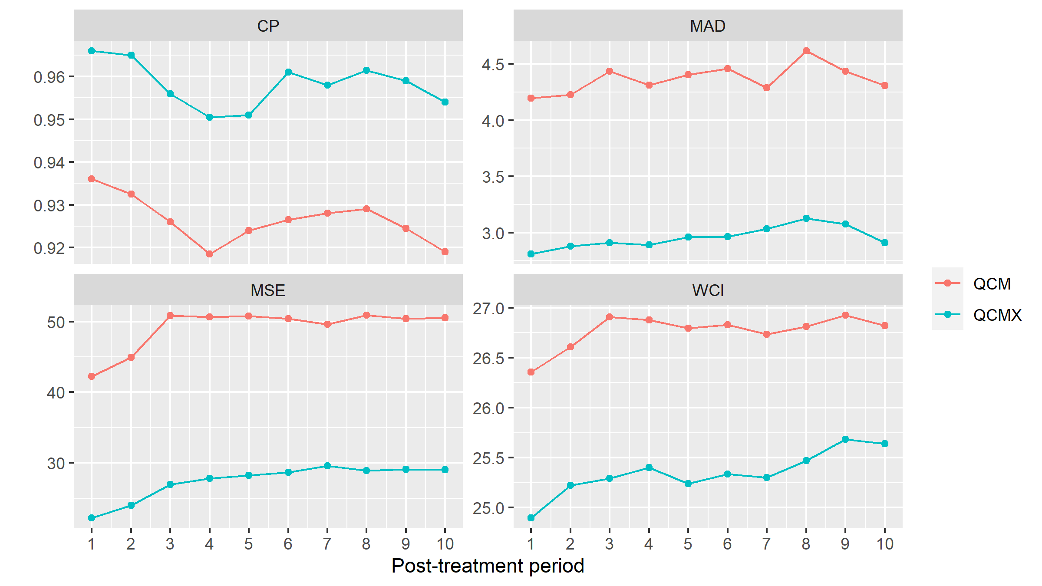

FIGURE 1 Plot of simulation result for DGP1 when N = 40 and T = 70

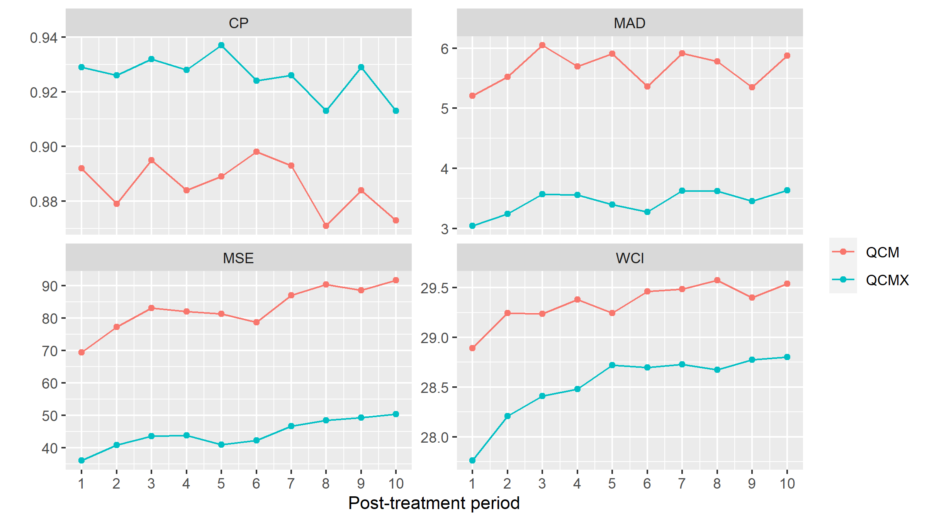

FIGURE 2 Plot of simulation result for DGP2 when N = 40 and T = 70

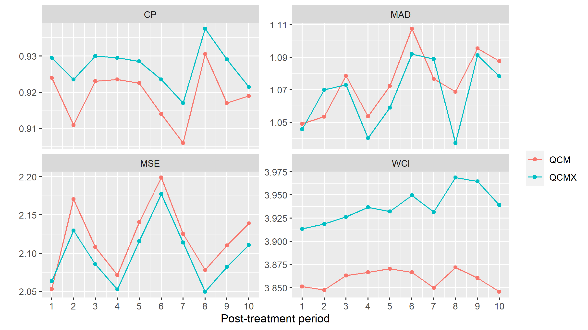

FIGURE 3 Plot of simulation result for DGP3 when N = 40 and T = 70

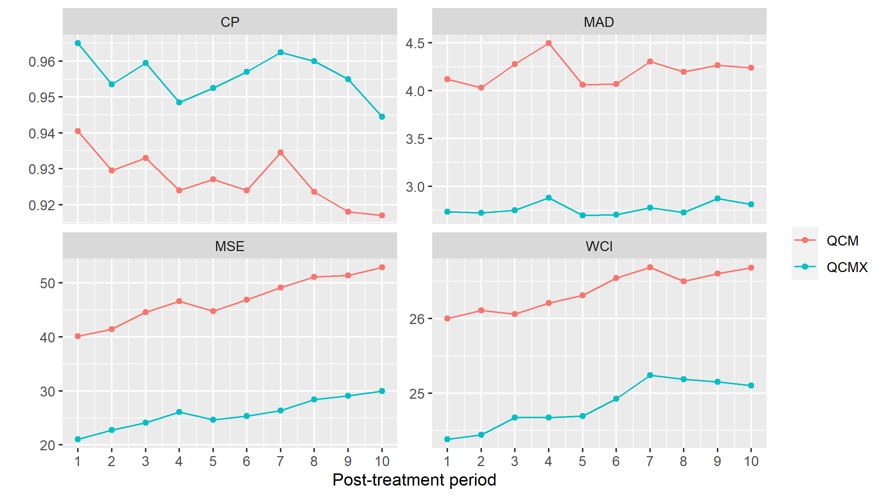

FIGURE 4 Plot of simulation result for DGP4 when N = 40 and T = 70

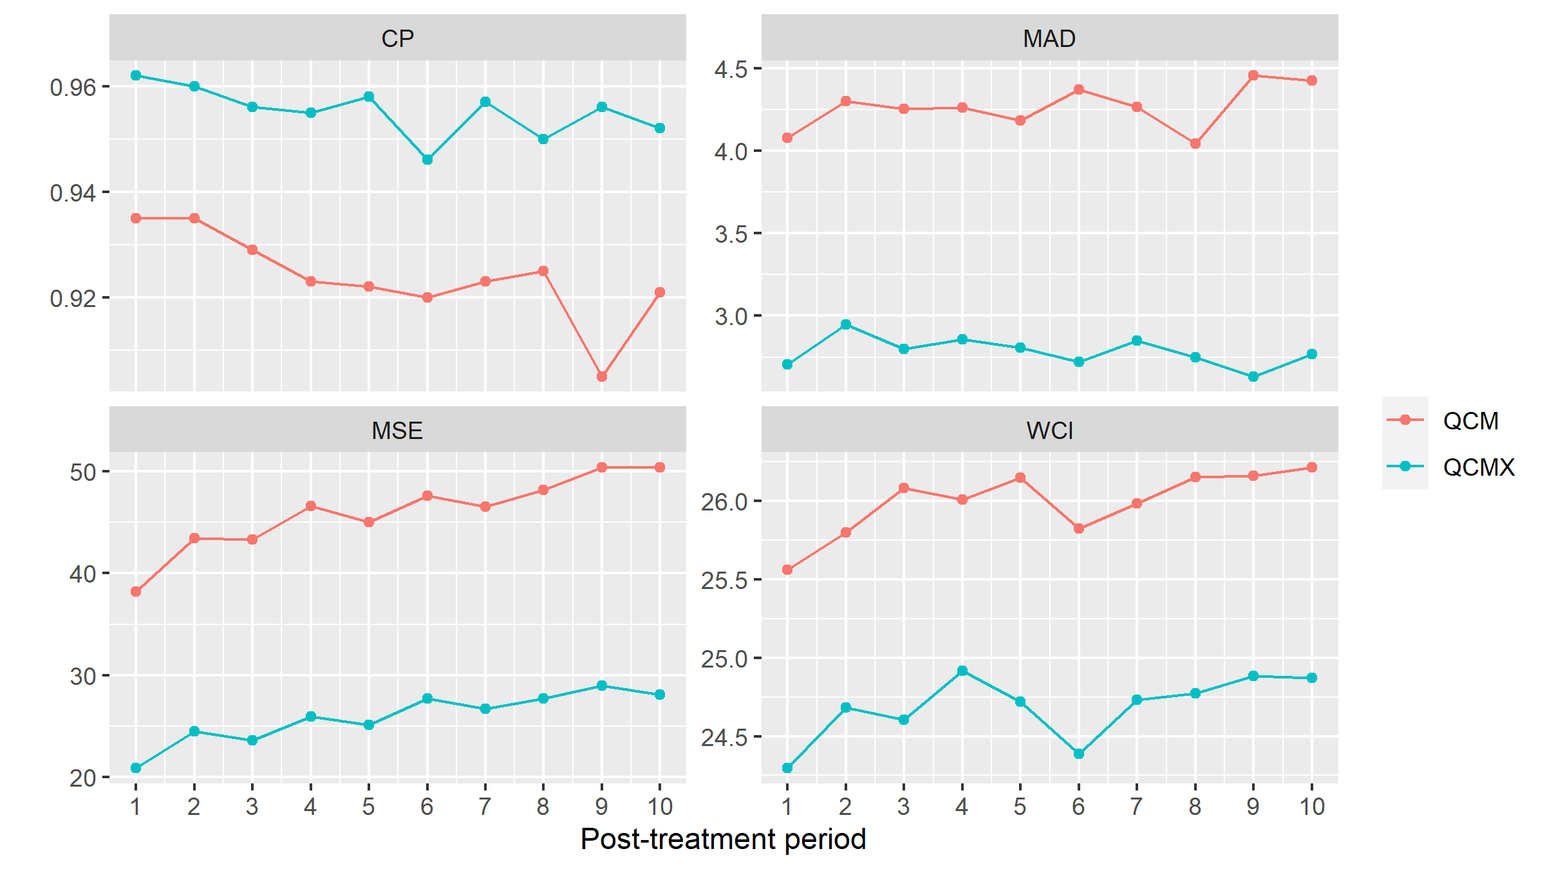

FIGURE 5 Plot of simulation result for DGP5 when N = 40 and T = 70

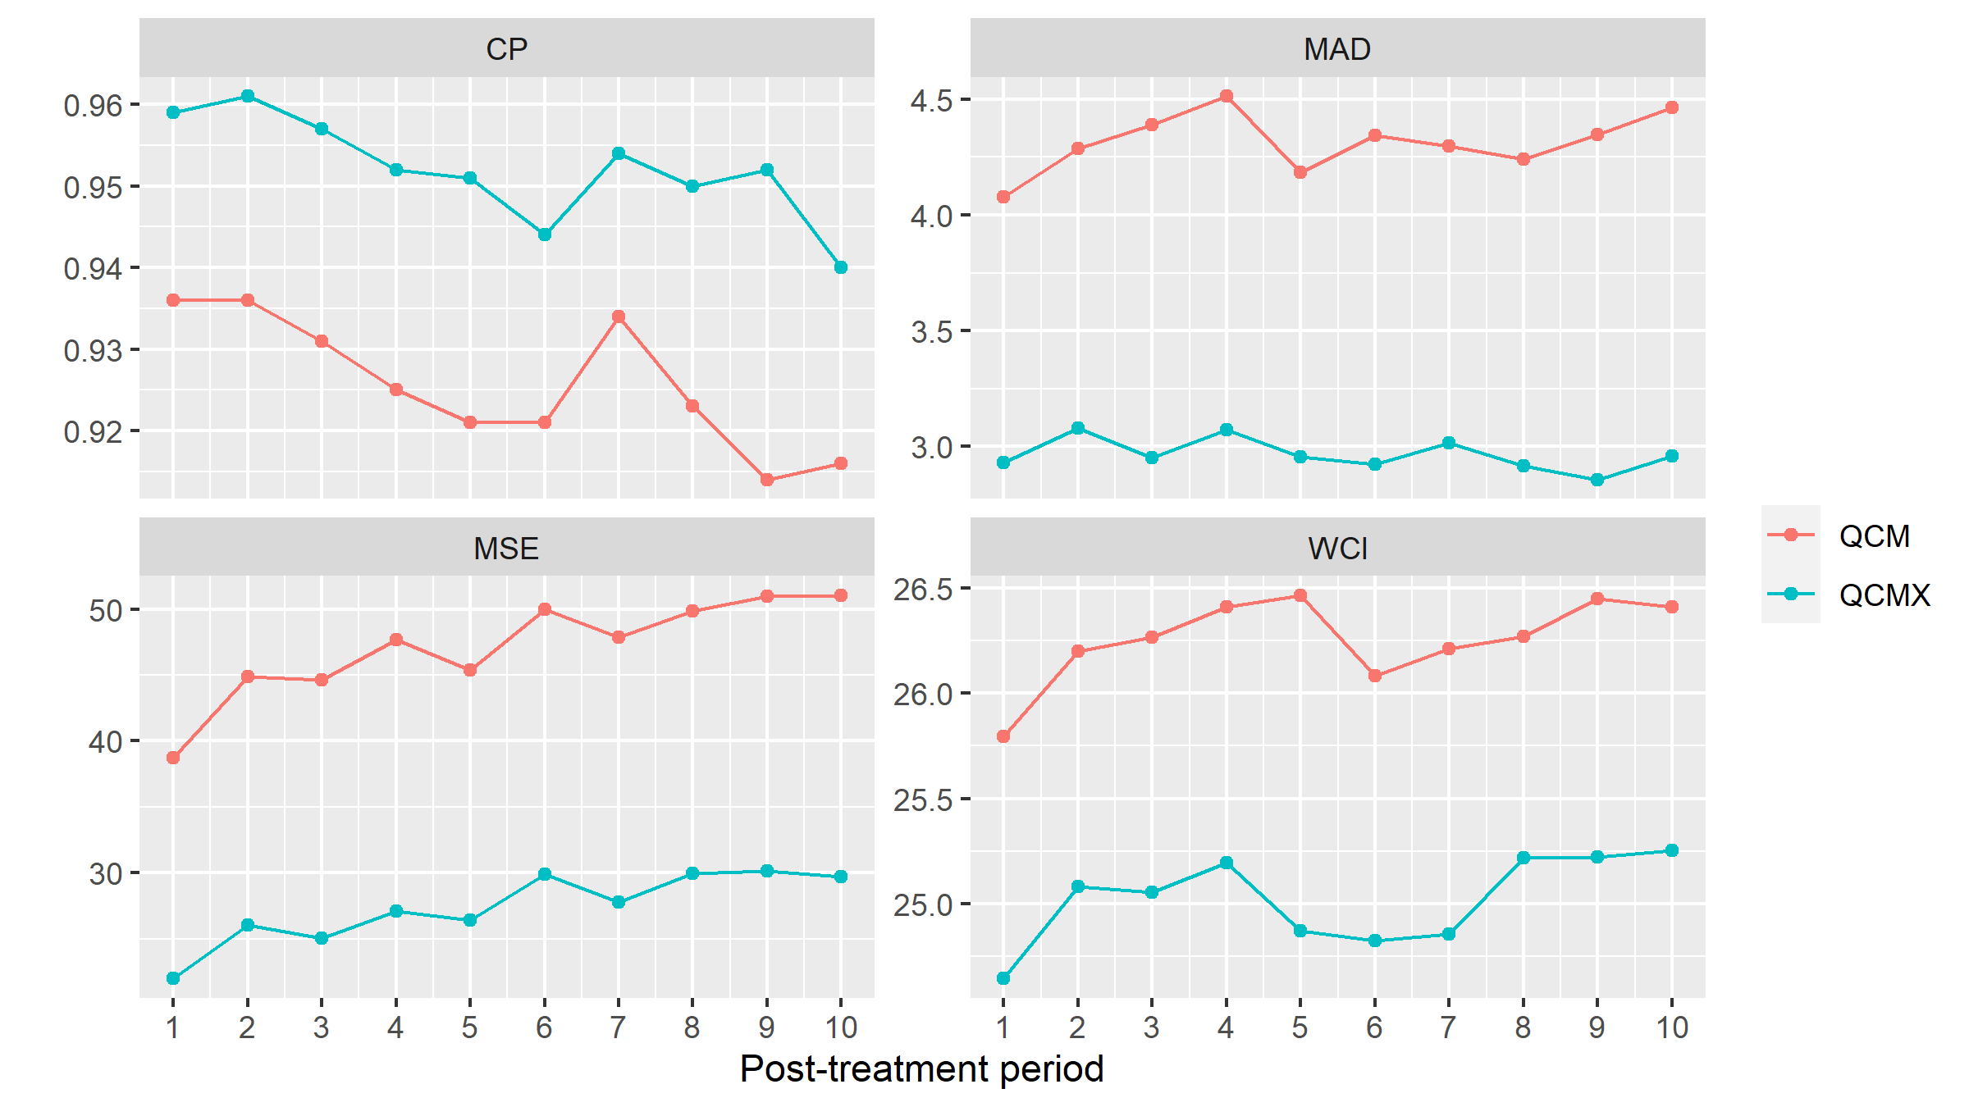

FIGURE 6 Plot of simulation result for DGP6 when N = 40 and T = 70

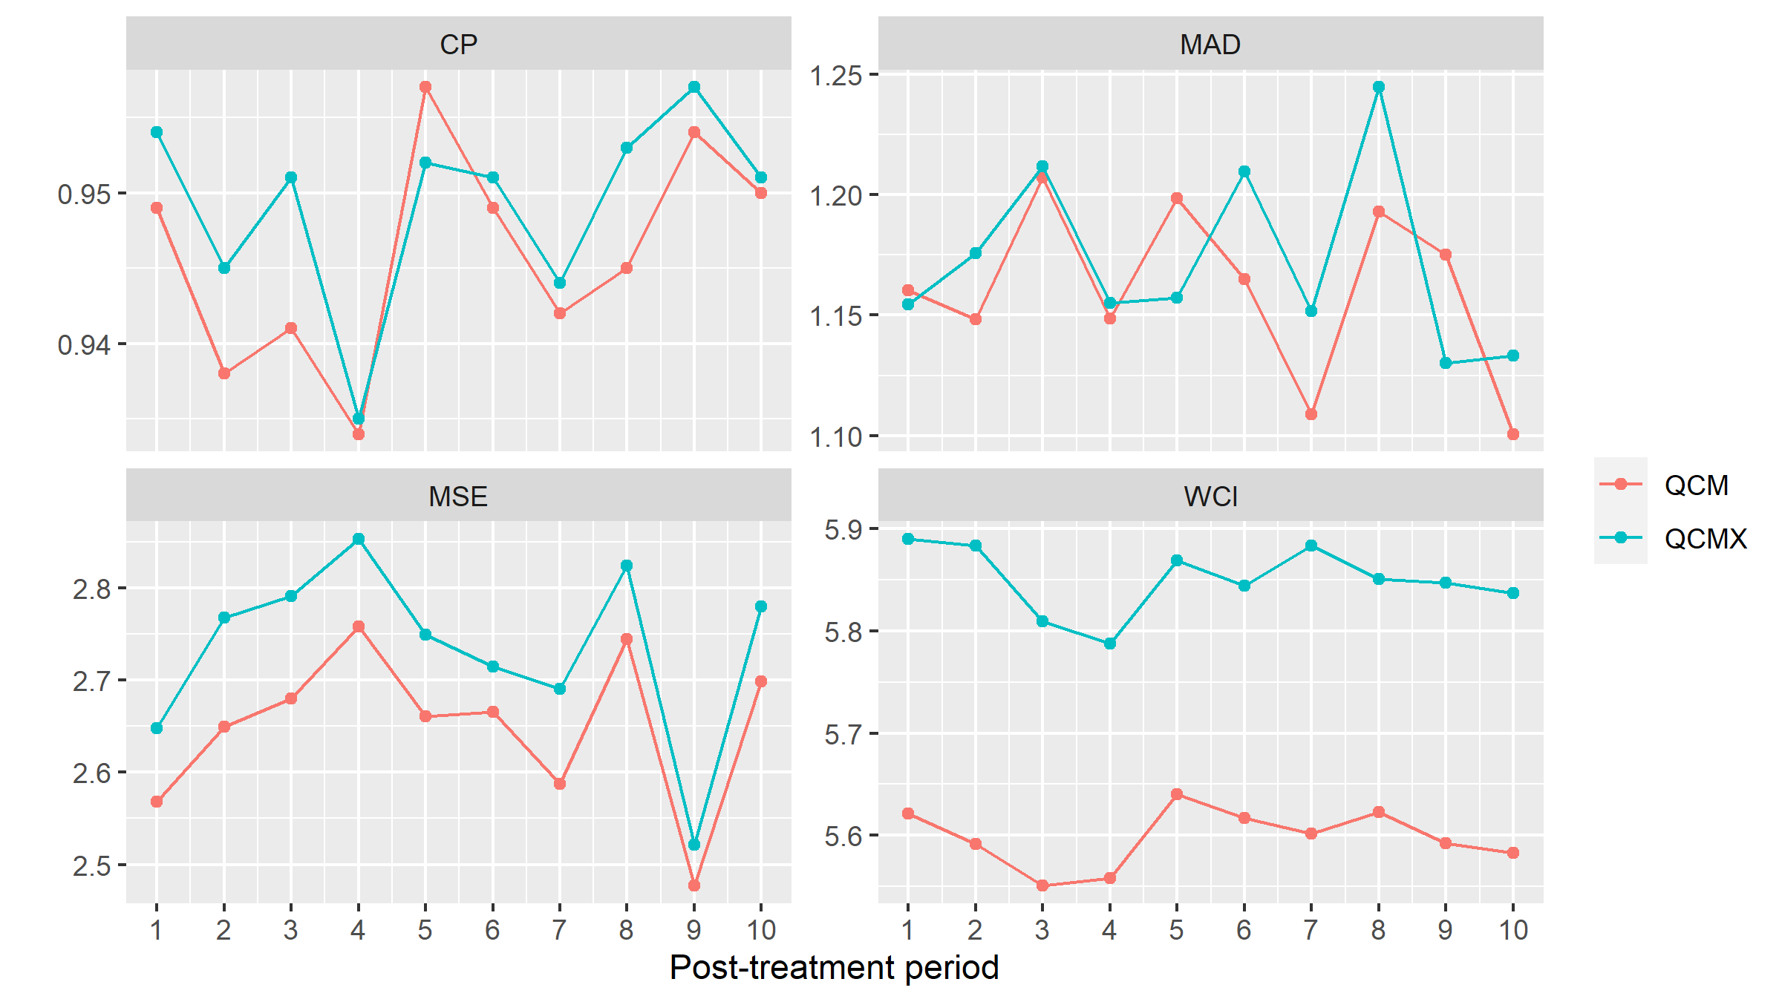

FIGURE 7 Plot of simulation result for DGP7 when N = 40 and T = 70